The Mayor and Board of Commissioners of the Town of Englewood met on Monday June 9, 2014 for a Public Hearing at 5:30 PM, followed in regular session at 6:00 PM in the community center meeting room.

**CALL TO ORDER**

Mayor Tony Hawn called the meeting to order.

**ROLL CALL**

City Recorder Sondra Denton called the meeting to order with commissioners Alan Phillips, Jerry Shirk, Jeanne Nichols and Wes Atwell present. Town Manager Jamie Moses, Police Chief Gary Miller and the city attorney Russell Blair were also present at the meeting.

**INVOCATION**Commissioner Shirk gave the invocation.

**COMMUNICATIONS FROM THE MAYOR**Mayor Hawn told the Board that the Central Interact Club had donated $150.00 to go toward the swimming pool and $50.00 for the library.

**COMMISSIONER REPORTS**

There were no commissioner reports.

**OLD BUSINESS:**

**LAST READING OF ORDINANCE # 06-09-14-83;**

AN ORDINANCE OF THE TOWN OF ENGLEWOOD, TENNESSEE

ADOPTING A BUDGET AMENDMENT ORDINANCE FOR THE 2013-2014 FISCAL YEAR

Whereas, the Mayor and Board of Commissioners of the Town of Englewood deem it necessary to amend the 2013-2014 Fiscal Year Budget with the following budget amendments:

Whereas, the State of Tennessee Comptroller’s Office changed the mandatory requirements concerning each municipality and their Certified Municipal Finance Officer (CMFO). Before July 1, 2013 the CMFO could contract with a municipality and the municipality not be faced with fines from the Comptroller’s Office, but in July 2013 the law was amended which required municipalities to have a CMFO employed or face fines up to $1,500.00 a month. Therefore, the Town Manager asked CMFO Sondra Denton to take the position as the town’s CMFO. Denton then told the Town Manager that she would change her status from contractual to employee. Also, due to the lack of man power within the maintenance department the Town Manager deemed it a benefit to the town to hire an additional employee for that department. Because of this these two employees were not part of the original budget, and;

Whereas, due to increased turnover in the Police Department the Town Manager increased the Police Departments base salary to be more in line with the surrounding cities, and

Whereas, the Water Plant had a pond that had to be cleaned out and the town had not anticipated this expense, and;

Whereas, the town has replaced gas lines that were not originally budgeted to be replaced, and;

**NOW, THEREFORE BE IT ORDAINED BY THE TOWN OF ENGLEWOOD, TENNESSEE AS FOLLOWS**

Section 1.





**Motion** was made by Phillips, seconded Nichols to Final Reading Ordinance # 06-09-14-83. All Ayes

**LAST READING OF ORDINANCE # 06-09-14-84;**

AN ORDINANCE OF THE TOWN OF ENGLEWOOD, TENNESSEEADOPTING THE ANNUAL BUDGET AND TAX RATE FOR THE FISCAL YEAR BEGINNING JULY 1, 2014 AND ENDING JUNE 30, 2015

WHEREAS, *Tennessee Code Annotated* Title 9 Chapter 1 Section 116 requires that all funds ‘

of the State of Tennessee and all its political subdivisions shall first be appropriated

before being expended and that only funds that are available shall be appropriated;

and

WHEREAS, the Municipal Budget Law of 1982 requires that the governing body of each municipality

adopt and operate under an annual budget ordinance presenting a financial plan with at

least the information required by the state statute, that no municipality may expend any moneys regardless of the source except in accordance with a budget ordinance and that

the governing body shall not make any appropriation in excess of estimated available

funds; and

WHEREAS, the Board of Mayor and Alderman has published the annual operating budget and

Budgetary comparisons of the proposed budget with the prior year (actual) and the

current year (estimated) in a newspaper of general circulation not less than ten (10)

days prior to the meeting where the Board will consider final passage of the budget.

NOW THEREFORE BE IT ORDAINED BY THE BOARD OF MAYOR AND ALDERMAN OF THE TOWN OF ENGLEWOOD, TENNESSEE AS FOLLOWS:

SECTION 1. That the governing body estimates anticipated revenues of the municipality from

all sources to be as follows for fiscal year 2015:

The General Fund and Solid Waste Funds are combined in the General Fund for reporting purposes.



Please note the Department of Audit has given the Town of Englewood, Tennessee permission to include the State Street Aid Fund in with the General Fund.



Section 2. That the governing body appropriates from these anticipated revenues and unexpended

and unencumbered funds as follows:

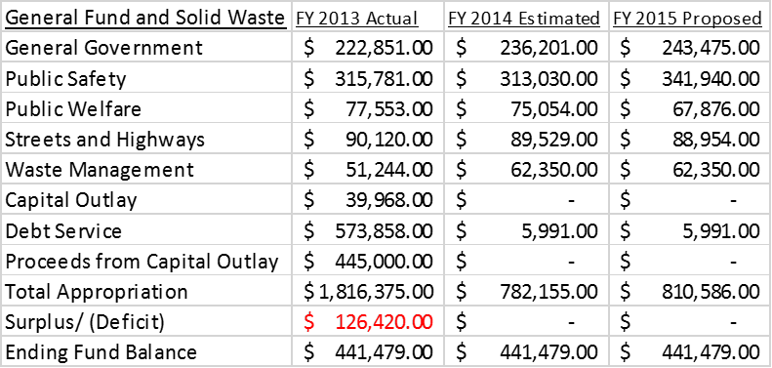



Section 3: At the end of the 2015 fiscal year the governing body estimates balances/ (deficits) as  
 follows:

General Fund $ 441,479.00

Drug Fund $ 41,260.00

Section 4: That the governing body recognizes that the municipality has bonded and other  
 indebtedness as follows:



Section 5: No appropriation listed above may be exceeded without an amendment of the budget  
ordinance as required by the Municipal Budget Law of 1982 T.C.A. Section 6-56-208. In addition, no appropriation may be made in excess of available funds except to provide for an actual emergency threatening the health, property or lives of the inhabitants of the municipality and declared by a two-thirds (2/3) vote of at least a quorum of the governing body in accord with Section 6-56-205 of the *Tennessee Code Annotated.*

Section 6: Transfer of unencumbered appropriations. At any time during the fiscal year the Board of Commissioners may transfer part or all of any unencumbered appropriation balance among programs within department, office or agency and the Board of Commissioners may by resolution transfer part or all of any unencumbered appropriation balance from one department, office, or agency to another.

Section 7: A detailed financial plan will be attached to this budget and become part of this budget ordinance. In addition, the published operating budget and budgetary comparisons shown by fund with beginning and ending fund balances and the number of full time equivalent employees required by Section 6-56-206, *Tennessee Code Annotated* will be attached.

Section 8: If for any reason a budget ordinance is not adopted prior to the beginning of the next fiscal year, the appropriations in this budget ordinance shall become the appropriations for the next fiscal year until the adoption of the new budget ordinance in accordance with Section 6-56-210, *Tennessee Code Annotated* provided sufficient revenues are being collected to support the continuing appropriations for no longer than 60 days after the end of the fiscal year. Approval of the Director of the Office of State and Local Finance in the Comptroller of the Treasury for a continuation budget will be requested if any indebtedness is outstanding.

Section 9: There is hereby levied a property tax of $1.44 per $100 of assessed value on all real and personal property.

Section 10: All unencumbered balances of appropriations remaining at the end of the fiscal year shall lapse and revert to the respective fund balances.

Section 11: This ordinance shall take effect upon its final passage, the public welfare requiring it.

Motion was made by Phillips, seconded by Atwell to pass on Final Reading Ordinance # 06-09-14-84. All Ayes

**NEW BUSINESS:**

**FIRST READING OF ORDINANCE # 06-09-14-85**

**Motion** was made by Phillips, seconded by Atwell to pass on first reading Ordinance # 06-09-14-85; an ordinance amending the 2013-2014 Fiscal Year Budget to account for the purchase of a 2014 Dodge Ram which will be used by the Maintenance Department and repair three (3) leaks on natural gas system. All Ayes (A copy or the ordinance may be obtained on our website at [www.townofenglewood.com](http://www.townofenglewood.com) and at City Hall.

**LIBRARY HOURS**

Town Manager Moses addressed the Board concerning the Library hours of operation. She said that with the new state law regarding health insurance requires the town to offer health insurance to employees who work thirty (30) hours a week and if the Library hours remains at thirty (30) hours, then the town would have to budget for the insurance coverage. Phillips then said that he believed the town was exempt from that requirement because it does not have fifty (50) full time employees. After further discussion the Board decided to Table this business until Denton could contact Athens Insurance regarding the law. **Motion** was then made by Phillips, seconded by Nichols to Table this business. All Ayes

**FINANCIAL REPORT**

Town Manager Moses presented the May 2014 Financial report to the Board. Moses said the revenues are looking really good and she appreciates the hard work of all the employees of the town. Phillips then questioned the revenues regarding property taxes. He felt the amount collected was lower than anticipated. Denton then explained that the budget was originally based on an assessed value of 15 million and the actual assessed value was 14 million. Motion was then made by Phillips, seconded by Nichols to approve the Financial Report. All Ayes

**POLICE DEPT. REPORT**

Police Chief Gary Miller presented the May 2014 Police Department report to the Board.

**FIRE DEPT. REPORT**

Moses read the Fire Department report.

**MAY MINUTES**

**Motion** was made by Phillips, seconded by Nichols to approve the May 2014 Minutes. All Ayes

**ADJOURNMENT**

**Motion** was made by Phillips, seconded by Nichols to adjourn the meeting. All Ayes

_Tony Hawn_________ __Sondra Denton______________  
Mayor Recorder